Install Guide

Requirement software: SQL Server 2005 and Net bean 5.5

Step 1: Attach rar file name eProject on your mail.

Step 2: Run DBExcellOnConsultingServiceQuery.sql file to create database.

Start 🡪 Programs 🡪 Microsoft SQL Server 2005 🡪 SQL Server Management Studio

+ Login your sqlServer

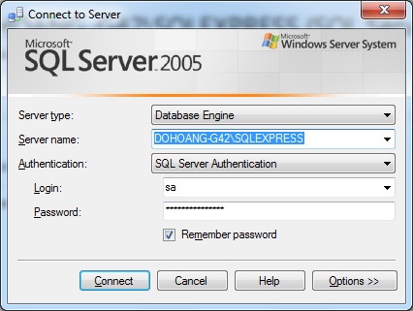

+ Execute query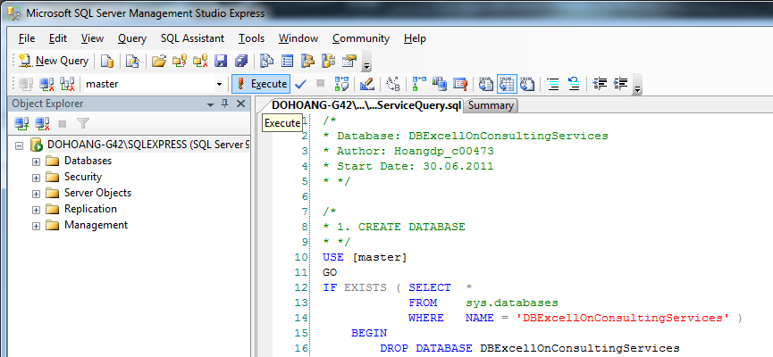

Step 3: Run website

+ Run Microsoft Visual Studio 2008

Start 🡪 Programs 🡪 Microsoft Visual Studio 2008🡪 Microsoft Visual Studio 2008

+ Config web.config file

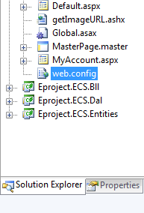

+ Recomment connectionStrings tag

- If you use express version of SQl Server

<add name="ECS" connectionString="Data Source=(local)\SqlExpress;Initial Catalog=DBExcellOnConsultingServices;Integrated Security=True" />

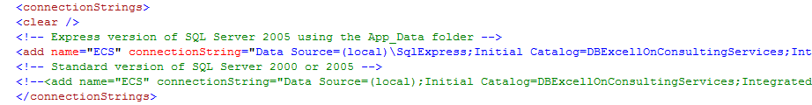

- If you use standart version of SQl Server

<add name="ECS" connectionString="Data Source=(local);Initial Catalog=DBExcellOnConsultingServices;Integrated Security=True;" />

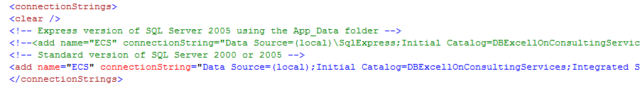

+ Choice Start Without Debugging or Press Ctrl + F5 to run website

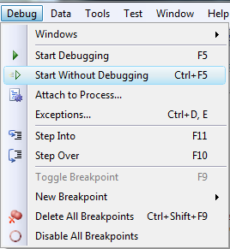

+ Login with an account of the following:

|  |  |  |
| --- | --- | --- |
| Role | User Name | Password |
| Administrator | admin | 123456 |
| HR Manager | hrmanager | 123456 |
| Service Manager | servicemanager | 123456 |
| Service Employee | serviceemployee | 123456 |
| Employee | employee | 123456 |